 | National University  of Computer and Emerging Sciences  Chiniot-Faisalabad Campus  Department of Artificial Intelligence and Data Science | 
Course Code | AI4002
Course Title | Computer Vision – Lab
Lab Task | 6
Due Date | 30 September 2025
Instructions:
- Rename this Word file as LT6_22F-3170
- If found plagiarism, straight zero will be marked against task.
- Submit task on Due Date. No Late Submission will be Tolerated.

Question 1
Write a Python code that reads the attached 2D Grayscale Image having Gaussian Noise. Use the OpenCV library to remove the gaussian noise of that image. Use:
- Linear Filters like Gaussian Filter and Wiener Filter
- Non-linear Filters like Bilateral filtering and Non-Local Means (NLM)

At the End, the Original Image with these methods, will be shown side by side, like 4 Rows into 2 Columns (Each Row will show Original Image with Filtered Image).

Code
import cv2
import numpy as np
import matplotlib.pyplot as plt

img = cv2.imread('gaussian_noise_practice_image.jpg', cv2.IMREAD_GRAYSCALE)

if img is None:
raise FileNotFoundError("Image not found! Please check the filename/path.")

# (A) Gaussian Filter (Linear)
gaussian_filtered = cv2.GaussianBlur(img, (5, 5), 0)

# (B) Wiener Filter (Linear) - Not in OpenCV directly, using SciPy
from scipy.signal import wiener
wiener_filtered = wiener(img, (5, 5))
wiener_filtered = np.uint8(np.clip(wiener_filtered, 0, 255))

# (C) Bilateral Filter (Non-linear)
bilateral_filtered = cv2.bilateralFilter(img, d=9, sigmaColor=75, sigmaSpace=75)

# (D) Non-Local Means (NLM) (Non-linear)
nlm_filtered = cv2.fastNlMeansDenoising(img, None, h=10, templateWindowSize=7, searchWindowSize=21)

plt.figure(figsize=(10, 14))

# Row 1: Gaussian
plt.subplot(4, 2, 1), plt.imshow(img, cmap='gray'), plt.title("Original (Noisy)")
plt.axis("off")
plt.subplot(4, 2, 2), plt.imshow(gaussian_filtered, cmap='gray'), plt.title("Gaussian Filter")
plt.axis("off")

# Row 2: Wiener
plt.subplot(4, 2, 3), plt.imshow(img, cmap='gray'), plt.title("Original (Noisy)")
plt.axis("off")
plt.subplot(4, 2, 4), plt.imshow(wiener_filtered, cmap='gray'), plt.title("Wiener Filter")
plt.axis("off")

# Row 3: Bilateral
plt.subplot(4, 2, 5), plt.imshow(img, cmap='gray'), plt.title("Original (Noisy)")
plt.axis("off")
plt.subplot(4, 2, 6), plt.imshow(bilateral_filtered, cmap='gray'), plt.title("Bilateral Filter")
plt.axis("off")

# Row 4: NLM
plt.subplot(4, 2, 7), plt.imshow(img, cmap='gray'), plt.title("Original (Noisy)")
plt.axis("off")
plt.subplot(4, 2, 8), plt.imshow(nlm_filtered, cmap='gray'), plt.title("NLM Filter")
plt.axis("off")

plt.tight_layout()
plt.show()

Screenshot
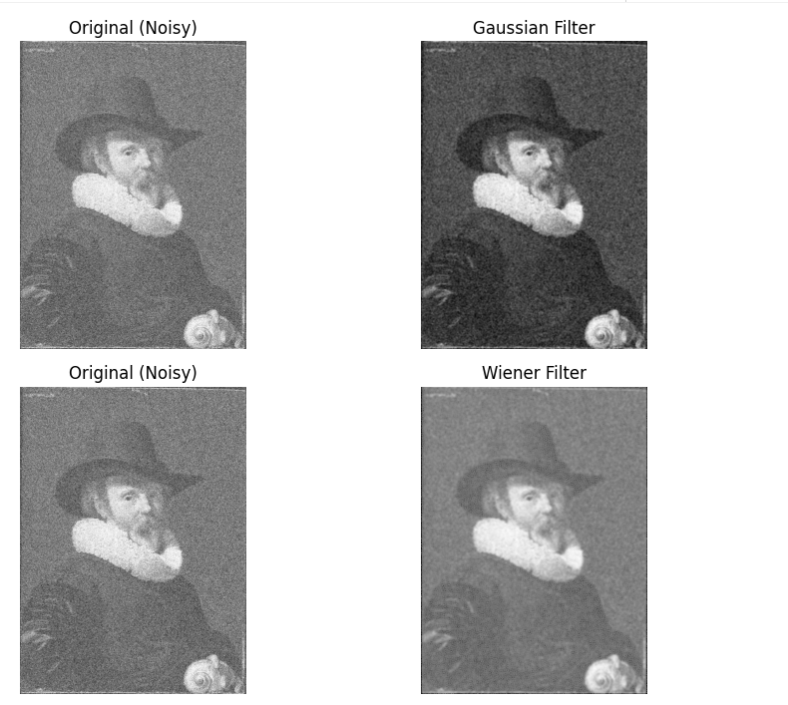

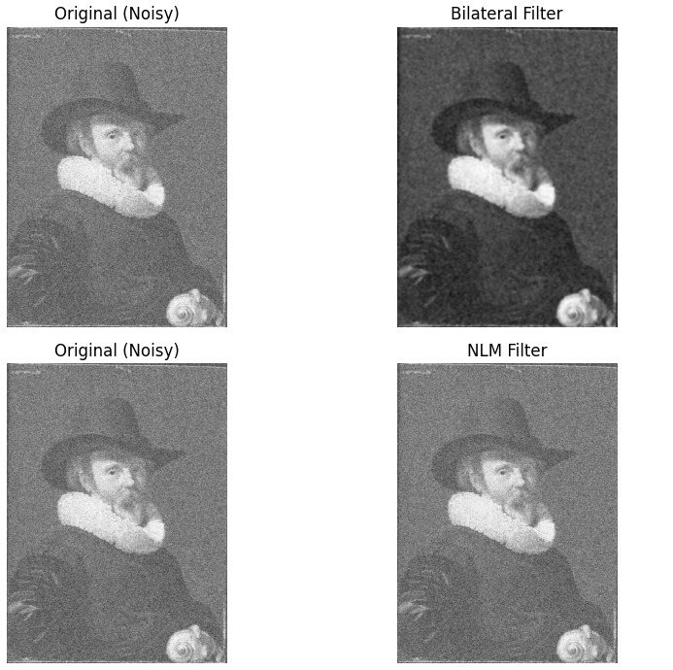

Question 2
Write a Python code that reads the attached 2D Grayscale Images with Salt and Pepper Noise (Low and High Percentage). Use the OpenCV library to remove the salt and pepper noise from these images one by one. Use:
- Median Filter
- Alpha-Trimmed Mean Filter
At the End, the Original Image with these methods will be shown side by side, like 2 Rows into 2 Columns (Each Row will show the Original Image with the Filtered Image).

Code
import cv2
import numpy as np
import matplotlib.pyplot as plt
from google.colab import files

images = ['salt_n_pepper_practice_image_1.jpeg', 'salt_n_pepper_practice_image_2.jpeg']

# Alpha-Trimmed Mean Filter
def alpha_trimmed_mean_filter(img, ksize=5, d=2):
pad = ksize // 2
padded_img = cv2.copyMakeBorder(img, pad, pad, pad, pad, cv2.BORDER_REFLECT)
result = np.zeros_like(img, dtype=np.float32)

for i in range(img.shape[0]):
for j in range(img.shape[1]):
window = padded_img[i:i+ksize, j:j+ksize].flatten()
window.sort()
trimmed = window[d:len(window)-d]
result[i, j] = np.mean(trimmed)
return np.uint8(result)

plt.figure(figsize=(12, 8))

for row, fname in enumerate(images, start=1):
img = cv2.imread(fname, cv2.IMREAD_GRAYSCALE)

# Median filter
median_filtered = cv2.medianBlur(img, 5)

# Alpha-Trimmed Mean filter
alpha_filtered = alpha_trimmed_mean_filter(img, ksize=5, d=2)

# Show results in same scale
plt.subplot(2, 3, (row-1)*3+1), plt.imshow(img, cmap='gray', aspect='auto')
plt.title(f"Original ({fname})"), plt.axis("off")

plt.subplot(2, 3, (row-1)*3+2), plt.imshow(median_filtered, cmap='gray', aspect='auto')
plt.title("Median Filter"), plt.axis("off")

plt.subplot(2, 3, (row-1)*3+3), plt.imshow(alpha_filtered, cmap='gray', aspect='auto')
plt.title("Alpha-Trimmed Mean"), plt.axis("off")

plt.tight_layout()
plt.show()

Screenshot
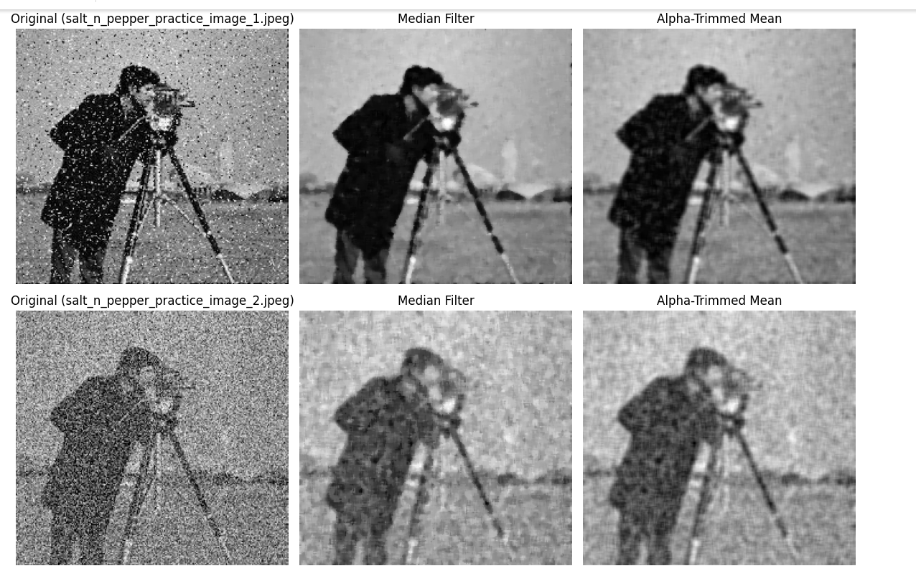

import cv2
import numpy as np
import matplotlib.pyplot as plt

# -----------------------------
# Alpha-Trimmed Mean Filter
# -----------------------------
def alpha_trimmed_mean_filter(img, k=3, d=2):
pad = k // 2
padded = cv2.copyMakeBorder(img, pad, pad, pad, pad, cv2.BORDER_REPLICATE)
output = np.zeros_like(img)

for i in range(img.shape[0]):
for j in range(img.shape[1]):
window = padded[i:i+k, j:j+k].flatten()
window.sort()
trimmed = window[d//2 : -(d//2)]
output[i, j] = int(np.mean(trimmed))

return output

# -----------------------------
# Read Images
# -----------------------------
img_low = cv2.imread("image_1.jpeg", cv2.IMREAD_GRAYSCALE)
img_high = cv2.imread("image_2.jpeg", cv2.IMREAD_GRAYSCALE)

if img_low is None or img_high is None:
print("Images not loaded. Check paths!")
else:
# =============================
# MEDIAN FILTER
# =============================
median_low = cv2.medianBlur(img_low, 3)
median_high = cv2.medianBlur(img_high, 3)

plt.figure(figsize=(10, 8))

plt.subplot(2, 2, 1)
plt.title("Original (Low Noise)")
plt.imshow(img_low, cmap='gray')
plt.axis("off")

plt.subplot(2, 2, 2)
plt.title("Median Filtered (Low Noise)")
plt.imshow(median_low, cmap='gray')
plt.axis("off")

plt.subplot(2, 2, 3)
plt.title("Original (High Noise)")
plt.imshow(img_high, cmap='gray')
plt.axis("off")

plt.subplot(2, 2, 4)
plt.title("Median Filtered (High Noise)")
plt.imshow(median_high, cmap='gray')
plt.axis("off")

plt.suptitle("Median Filter Results")
plt.tight_layout()
plt.show()

# =============================
# ALPHA-TRIMMED MEAN FILTER
# =============================
alpha_low = alpha_trimmed_mean_filter(img_low, k=3, d=2)
alpha_high = alpha_trimmed_mean_filter(img_high, k=3, d=2)

plt.figure(figsize=(10, 8))

plt.subplot(2, 2, 1)
plt.title("Original (Low Noise)")
plt.imshow(img_low, cmap='gray')
plt.axis("off")

plt.subplot(2, 2, 2)
plt.title("Alpha-Trimmed (Low Noise)")
plt.imshow(alpha_low, cmap='gray')
plt.axis("off")

plt.subplot(2, 2, 3)
plt.title("Original (High Noise)")
plt.imshow(img_high, cmap='gray')
plt.axis("off")

plt.subplot(2, 2, 4)
plt.title("Alpha-Trimmed (High Noise)")
plt.imshow(alpha_high, cmap='gray')
plt.axis("off")

plt.suptitle("Alpha-Trimmed Mean Filter Results")
plt.tight_layout()
plt.show()

